McKinsey Hours: The Honest Read
Meta description: McKinsey hours in 2026: the 55 to 65 hour week day by day, what sets your hours, the weeks between studies, travel, weekends, AI tools and team norms.

McKinsey hours come to about 55 to 65 a week for a consultant on a client project, and a first-year Business Analyst should plan on 60. Hacking the Case Interview's hours page, updated in May 2026, puts the McKinsey, BCG and Bain average at 55 to 65 hours a week, with peaks of 70 to 80 or more before big client meetings. [VERIFY: Hacking the Case Interview hours page, May 2026] In this article, I lay out the McKinsey week day by day, the three things that set your hours, the weeks between studies, travel, weekends, what AI tools have changed, and how team norms work.

How many hours do McKinsey consultants work?
About 60 a week while staffed on a study, with a normal range of 55 to 65 and peaks in the 70s before big client meetings. A study is McKinsey's word for a client project, "staffed" means assigned to one, and a Business Analyst is staffed most of the year. The trackers land close together. Hacking the Case Interview's hours page says 55 to 65 with peaks of 70 to 80 or more, and cites Glassdoor reviews from first-year MBB analysts reporting average weeks of 60 [VERIFY: Hacking the Case Interview, May 2026]. StrategyCase, written by a former McKinsey consultant, says 50 to 80 hours while staffed, puts the honest average "in the low 60s," and gives 30 to 60 hours between studies [VERIFY: StrategyCase, July 2026]. A PrepLounge coach who worked at McKinsey puts the average day at 12 hours, "nine am to nine pm," which is 60 across five days [VERIFY: PrepLounge, June 2025]. Office matters a little: Hacking the Case Interview puts New York and Dallas at 60 to 65 hours and Amsterdam and Zurich at 50 to 55 [VERIFY: Hacking the Case Interview, May 2026]. Plan on 60 hours in a typical staffed week, 75 or more in the worst week of a study, and around 40 when you're between studies.

Are McKinsey hours better than investment banking hours?
Yes, by about 15 hours a week, and most of the gap is weekends. Mergers & Inquisitions puts first-year investment banking analysts at 70 to 80 hours in a normal week, with 100 or more in busy periods [VERIFY: Mergers & Inquisitions hours guide, 2026]. A McKinsey Business Analyst works about 60 hours a week and keeps most weekends, while a first-year banking analyst works 70 to 80 and usually works weekends too. Per hour worked, first-year pay comes out within a few dollars: about $47 at McKinsey and about $51 in banking [VERIFY: $135,000 McKinsey first-year cash from Hacking the Case Interview's 2026 salary page over 2,880 hours (60 a week for 48 weeks); about $185,000 banking first-year cash, the middle of Superday AI's Goldman Sachs range, over 3,600 hours (75 a week for 48 weeks)].

1. McKinsey hours are front-loaded into Monday through Wednesday
The average misleads because the hours aren't spread evenly across the week. They're stacked at the front.

A study can run anywhere from a few weeks to six months. Private equity work sits at the short end, two to four weeks, and strategy work at the long end, three to six months [VERIFY: Hacking the Case Interview, May 2026]. The team works the client's week, and the client's week peaks in the middle. Monday morning goes to travel and planning, Thursday afternoon goes to the trip home, so client meetings land on Tuesday, Wednesday and Thursday morning, and the work that feeds each meeting lands the night before. Monday through Wednesday are the long days. StrategyCase puts them at 10 to 16 hours each, and Hacking the Case Interview's day-by-day schedule has a client-site day at 12 to 14 hours of work, from an 8 a.m. team check-in to slide polish at 10 p.m. [VERIFY: StrategyCase, July 2026; Hacking the Case Interview, May 2026]. Thursday is shorter, 10 to 12 hours, because part of it is a client progress meeting and part of it is the trip home. Friday is the home-office day: a check-in with the partner, training, expenses, staffing conversations about the next study, and whatever slides need cleaning up before Monday. Six to eight hours, and nobody minds if you leave at 4:30.

Here's the week, built from the two trackers.

Day | Where you are | Typical hours | What fills them
Monday | Client site or home office | 12 to 14 | Travel out if the team is on site, the week's plan, first pass at the analysis
Tuesday | Client site | 12 to 14 | Client working sessions by day, model and slide work at night
Wednesday | Client site | 12 to 14 | The heaviest day: team problem solving, the deck for Thursday
Thursday | Client site, then home | 10 to 12 | Client progress meeting, the flight or drive home, email on the way
Friday | Home office | 6 to 8 | Partner check-in, training, expenses, staffing for the next study
Saturday and Sunday | Off | 0 to 2 | An hour or two of Sunday evening prep on some weeks

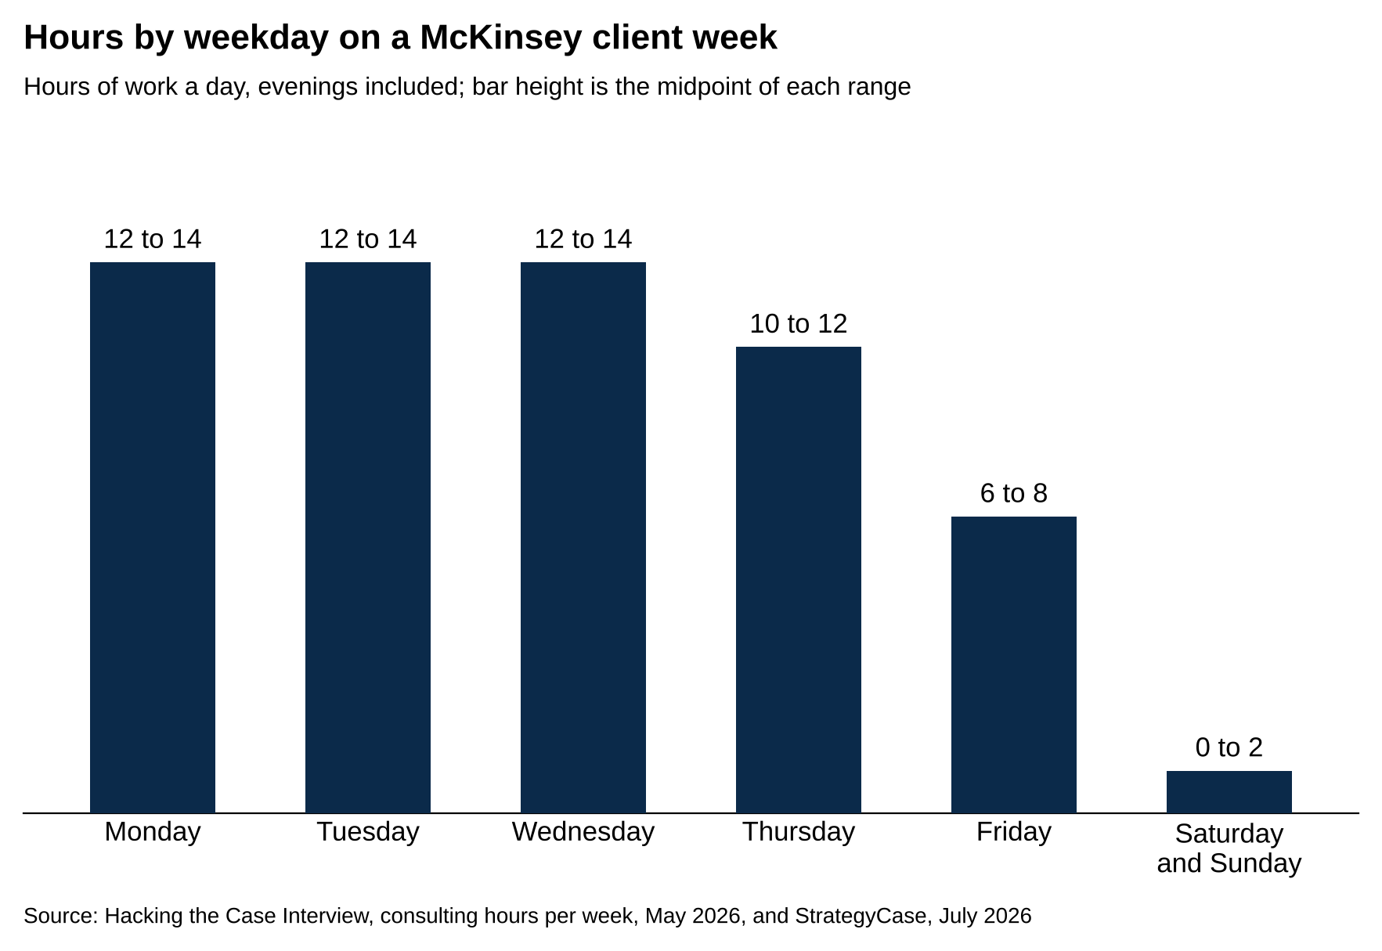
Monday through Wednesday run 12 to 14 hours each, Thursday 10 to 12 and Friday 6 to 8.
Source: Hacking the Case Interview, consulting hours per week, May 2026, and StrategyCase, July 2026.

Sources: Hacking the Case Interview hours page (May 2026) and StrategyCase hours page (July 2026). Hours are total work time, evenings included. [VERIFY: both trackers before publish]

Add the rows up and a 60-hour week stops being 12 hours a day for five days. It's three 13-hour days, an 11-hour day and a 7-hour day, which comes to 57, plus the Sunday hour or two that the trackers describe. Hacking the Case Interview's own version adds to 54 to 64 [VERIFY: Hacking the Case Interview, May 2026]. If you're deciding whether you can live with the job, decide about the Tuesdays and Wednesdays, not the average. The McKinsey week is three 13-hour days, an 11-hour day and a 7-hour day, so the real test is whether you can do the three long days in a row every week.

2. The study, the Engagement Manager and the client set your hours
Two Business Analysts in the same office in the same year can have different lives, and the difference comes down to three things. StrategyCase's 2026 read on working at McKinsey is blunt about two of them: "The single biggest determinant of your hours is not McKinsey, it is your engagement manager and your client" [VERIFY: StrategyCase, July 2026].

The first is where the study is in its life. The first two weeks, when the team is scoping the problem and collecting data, are moderate. The middle weeks, when the analysis gets built, are the grind. The week before a steering committee meeting is the peak. A steering committee meeting is the session where the senior client executives review the team's work and decide what happens next, and most studies have one every few weeks. The deck for that meeting gets rebuilt more than once in the days before it, and that's where midnight shows up. The last week, after the final presentation, is quiet. A study with three steering committees has three peaks, and you can see them on the calendar from day one.

The type of study stacks on top of the phases. A private equity due diligence is a study where a PE firm pays McKinsey to check a company it's about to buy, usually in two to four weeks before a bid deadline. Those run 12-hour days or more for the whole stretch, with weekends in play [VERIFY: PrepLounge, June 2025; Hacking the Case Interview, May 2026]. A long implementation study, where the team helps the client put a plan into practice over months, runs closer to 8 to 10 hours a day [VERIFY: PrepLounge, June 2025]. Business Analysts get staffed on both.

The second is the Engagement Manager. The Engagement Manager, or EM, is the consultant who runs the team day to day. The EM sits two or three levels above a Business Analyst, owns the workplan, reviews every page and decides when the team goes home. A good EM plans the work backward from the client meetings so the team isn't rebuilding the deck at 11 p.m. the night before. An EM who says yes to every partner request, or who doesn't plan, turns a 60-hour study into an 80-hour one. A Business Analyst doesn't pick the EM. You can ask around before a study starts, and people do.

The third is the client. A cost study for a manufacturer whose board meets in six weeks runs hot, because the board date can't move. A public sector organization study on a six-month timeline runs cooler. StrategyCase's travel note applies to evenings too: "Your travel load in 2026 is decided by your client, not by a firm policy" [VERIFY: StrategyCase, July 2026]. Your McKinsey hours are set by the study's calendar, the Engagement Manager's planning and the client's deadline, and none of those three is the average.

3. Weeks between studies run closer to 40 hours
The beach is consulting slang for the time between studies, when you're not assigned to a client. It's a real part of the year, and it's part of the 60-hour average.

When a study ends there's usually a gap of a few days to a few weeks before the next one starts. During the gap you work on internal projects, help a partner with a proposal for new work, do training, or interview candidates, and the week drops to something close to a normal job. StrategyCase puts beach weeks at 30 to 60 hours with an average in the low 40s [VERIFY: StrategyCase, July 2026]. Hacking the Case Interview says internal weeks between projects "were closer to 40" on its hours page and 30 to 40 on its work-life balance page [VERIFY: Hacking the Case Interview, May 2026]. How much of the year is beach depends on the office and the economy: when clients buy less work, more consultants sit unstaffed for longer. StrategyCase puts junior consultants' utilization, the share of their time billed to a client, at roughly 80 to 95 percent, so the beach is somewhere between two and ten weeks a year [VERIFY: StrategyCase hours page, July 2026].

The beach is also when vacation happens. Taking a week off in the middle of a study is hard on a team of three to six people, so most people plan trips for the gap [VERIFY: team size from StrategyCase's working-at-McKinsey page, July 2026]. McKinsey also has a formal version of the gap called Take Time. Take Time lets consultants take an extra 5 to 10 weeks of unpaid leave a year between studies, on top of normal vacation [VERIFY: mckinsey.com careers blog posts dated July 2018, June 2019 and July 2020, all live in October 2026; Hacking the Case Interview work-life balance page, May 2026, still says up to 10 weeks; confirm current terms with a recruiter].

The 60-hour figure is an average across staffed and unstaffed weeks, so the staffed weeks run above it. Say 44 weeks at 65 hours and 4 weeks at 42: that averages 63. The beach is why the McKinsey average looks livable, and the staffed weeks are why it sometimes doesn't feel that way.

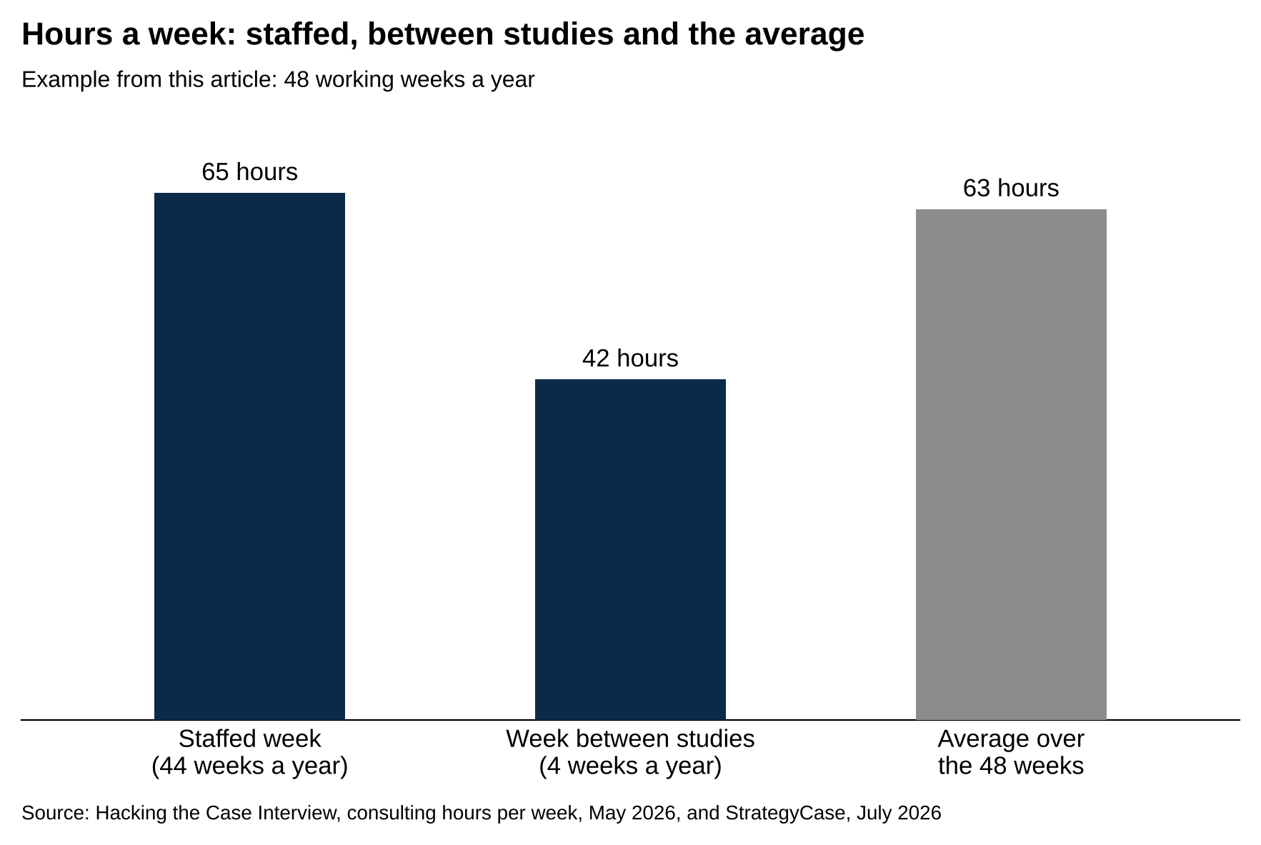
Forty-four weeks at 65 hours and four weeks at 42 average 63 hours a week.
Source: Hacking the Case Interview, consulting hours per week, May 2026, and StrategyCase, July 2026.

4. Travel adds hours nobody counts, and most teams now travel less
The reference pattern for McKinsey travel is Monday through Thursday at the client and Friday at the home office, and the trackers still describe it that way. What's changed is how many teams actually do it.

Hacking the Case Interview's May 2026 pages say teams "now spend 2 to 3 days on site with clients instead of the traditional 4 day travel week," and that McKinsey "assesses travel needs on a case-by-case basis rather than defaulting to four days on-site" [VERIFY: Hacking the Case Interview hours and work-life balance pages, May 2026]. StrategyCase says the same: "Most teams now travel two to three days a week," against the four-day model that was standard before 2020 [VERIFY: StrategyCase working-at-McKinsey page, July 2026]. McKinsey has no published days-per-week rule [VERIFY: no firm travel policy published as of October 2026]. Each team agrees its on-site days at the start of the study (section 7 covers how), and the client decides.

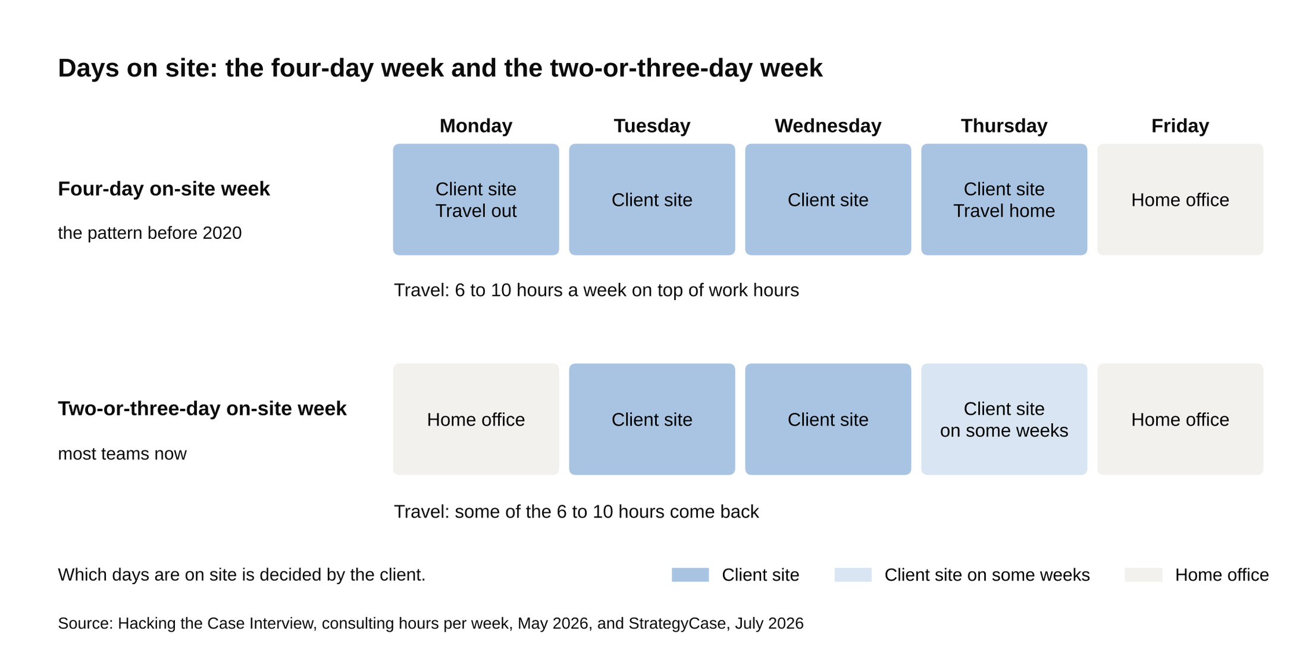
A four-day on-site week adds 6 to 10 hours of travel on top of work hours.
Source: Hacking the Case Interview, consulting hours per week, May 2026, and StrategyCase, July 2026.

Travel matters for hours because travel time is work time that doesn't show up in the analysis. Hacking the Case Interview counts it as "6 to 10 hours of travel per week on top of your actual working hours" [VERIFY: Hacking the Case Interview, May 2026]. Walk through a Monday: a 5 a.m. alarm for a 7 a.m. flight, an hour at the gate on email, a car to the client, and the same in reverse on Thursday. None of that time goes into the analysis, and all of it comes out of your week. A team on site two days a week instead of four gives six to ten hours back. It changes the evenings too. A night in your own apartment ends when you close the laptop. A night in a hotel where the whole team is still working downstairs tends to end when the EM's does.

If you're choosing between offers or offices, ask each consultant you talk to how many nights they were away last month. Travel adds six to ten uncounted hours to a McKinsey week, and the move to two or three days on site since 2020 has given some of that back.

5. Weekends are mostly yours, and the exceptions are predictable
Here's the direct answer on weekends: a Business Analyst at McKinsey works most weeknights and few weekends.

The trackers agree on it. Hacking the Case Interview's work-life balance page says that in Vault's 2026 survey "a majority of MBB consultants reported working weekends fewer than once per month," and its hours page calls weekend work "a last resort rather than an expectation" [VERIFY: Hacking the Case Interview work-life balance page, May 2026, citing Vault 2026]. StrategyCase: "Weekends are usually protected," with real weekend work "only in rare crunch periods" [VERIFY: StrategyCase, July 2026]. A PrepLounge coach who worked at McKinsey writes "I never worked one single weekend in my entire time at McKinsey," which is one person's experience and still a data point [VERIFY: PrepLounge, June 2025]. McKinsey's Business Analyst posting asks for the ability to "work or attend meetings outside of traditional business hours" and to "take on projects with limited or no notice at times," which is honest about the evenings and the unpredictability without promising anything about Saturdays [VERIFY: McKinsey Business Analyst posting, live October 2026].

The exceptions follow the pattern from section 2. The weekend before a final steering committee. A private equity due diligence with a bid due Monday morning. A client whose own team works Saturdays and expects the McKinsey team in the room. And recruiting season, when a Saturday of campus interviews is work even if it's enjoyable. CaseCoach, founded by a former McKinsey Engagement Manager, writes that weekend work is "frowned upon" and that "consulting teams actively avoid weekend working wherever possible" [VERIFY: CaseCoach, April 2023].

What McKinsey mostly protects is Friday night to Monday morning. What it doesn't protect is Tuesday night. If your question is whether you'll have weekends at McKinsey, the answer is mostly yes, and if your question is whether you'll have weeknights, the answer is mostly no.

6. AI tools have changed the evening work but not the deadlines
The long evenings in section 1 are mostly production work. After the client sessions end, the analyst updates the model with whatever data came in that day, turns the results into slides, and works through the EM's comments on each page so the deck is ready for the next morning's review. On a typical client-site day that loop runs from dinner until 10 p.m. or later, and it repeats before every client meeting [VERIFY: Hacking the Case Interview day-by-day schedule, May 2026].

AI tools now do part of that loop. Lilli, McKinsey's internal AI tool, was used every month by more than 75 percent of the firm's employees by mid-2025, mostly to search the firm's past work and draft first versions of research summaries and slides [VERIFY: Fortune, June 2, 2025, reporting Bloomberg]. In January 2026, CEO Bob Sternfels said the firm had saved about 1.5 million hours in a year on searching for and synthesizing information [VERIFY: Business Insider, January 2026]. Spread across the roughly 40,000 people he gave as the firm's headcount in the same talk, that's under an hour a week each [VERIFY: arithmetic, 1.5 million hours over 40,000 people over 48 weeks is about 0.8 hours a week].

The week hasn't shrunk to match. StrategyCase's July 2026 McKinsey page still puts the week at 55 to 70 hours, because AI tools sped up research and first drafts but the client meetings that create the peaks are on the same calendar. In its words, AI "absorbed the research and first-draft work" [VERIFY: StrategyCase, July 2026]. What's different is the job at 10 p.m.: checking Lilli's draft, finding what's wrong with it and fixing the logic, rather than typing the first version.

7. Team norms set each study's hours, and you can raise them
The most useful thing to know about McKinsey hours is that they're negotiated at the start of every study, in a conversation that happens before the first client meeting.

Every study starts with a team learning, a session where the new team talks about how it works best, and that's where the team sets its norms. Team norms are the rules the team agrees on for how it will work together. McKinsey's careers blog defines them as rules "we establish at the beginning of an engagement to help us all be at our best," and describes a survey every two weeks that asks the team, "Are we adhering to the norms we set in the team learning?" [VERIFY: McKinsey careers blog posts dated June 5 and September 6, 2019, both live in October 2026]. In practice, norms look like one protected night a week with no team work, a hard stop for the Thursday flight, no email after a set hour, and a weekly check-in where the EM asks how sustainable the week was. The same blog says teams "evaluate the best working model for their engagement before beginning work," including how many days to be on site, so the kickoff is also where the travel pattern from section 4 gets set [VERIFY: McKinsey careers blog, June 5, 2019].

A Business Analyst can't set the norms alone, but you can raise them, and the firm backs you when you do. CaseCoach writes that firms "closely monitor the hours that consultants work" and "penalize managers and Partners who overwork their teams, intervening when required," and Hacking the Case Interview says the same of McKinsey specifically [VERIFY: CaseCoach, April 2023; Hacking the Case Interview work-life balance page, May 2026]. The BA who says on Monday, "I have a commitment Wednesday at 8, can I do my slides after," almost always gets a yes. The BA who says nothing works the Wednesday and resents it. The same applies when a week goes wrong: say so at the check-in, with the specific night you lost, and the EM can fix the plan. Hours at McKinsey are set at the start of each study, and the Business Analyst who knows that conversation exists gets a different job from the one who doesn't.

What to say about hours in a McKinsey interview
Hours come up in the fit half of the interview, which at McKinsey is the Personal Experience Interview, and in your questions at the end. An answer about hours that names the study phase and the team norms shows the interviewer you've talked to people at the firm. Here are four questions and the answers that land.

How do you feel about the hours in consulting?

Don't say: "I'm fine with long hours. I worked hard in college and I'm used to it."

Say: "I've talked to two Business Analysts about it. The hours depend on the study phase and the team norms more than on the firm, so I'd want to be on a team that sets norms at kickoff and checks in weekly, and I'd go in expecting the long Tuesdays and Wednesdays rather than the quiet Fridays."

How do you feel about the travel?

Don't say: "I love to travel, so that's a perk for me."

Say: "I'm planning on two or three nights a week at a client on most studies and more on some. I'd want to know at the start of each study which days we're on site, so I can keep the nights at home for the things I've committed to."

What would you ask a team about its hours?

Don't say: "What's the work-life balance like?"

Say: "How many nights were you away last month, and what did your team's norms look like on your last study?"

How would you handle a week that gets out of control?

Don't say: "I'd push through. I don't mind an all-nighter."

Say: "I'd raise it at the team check-in with the specific nights I lost and what caused them, and ask the EM whether the plan for the steering committee week can move. I'd rather flag it early than let it build for three weeks."

What to do next
If you're holding a McKinsey offer or an interview, do two things this week. Before you accept, ask two current Business Analysts how many nights they were away last month and what their last team's norms were. Write the answers down next to the day-by-day table in section 1, and compare them with the Business Analyst role as the firm describes it. Then decide about the Tuesdays. If three 13-hour days in a row every week for two years is a trade you'd make for the training, the pay and the exits, the McKinsey salary 2026 post covers what the job pays, the guide to top consulting exit opportunities covers where people go after, and the guides to McKinsey Solve and breaking into MBB cover the prep.

